CHRISTMAS AT THE FOOD HUB

We realise that planning for Christmas this year is really hard without knowing how many people are allowed to gather in one place. But it’s proving just as hard for our suppliers who need to prepare too. As usual we are doing a pre-order list for items where our producers need a bit of lead in time. To try and make life easier for you our suppliers have done their best to cater for smaller family gatherings, and we have deliberately set the deadline for returning your order after the 4 week lockdown ends, by which time hopefully we will know the rules for Christmas.

We will be delivering to our pickup points as usual on Wednesday 16th and Friday December 18th, but we will only do deliveries on the southern route on Dec 23rd and there will be no northern route delivery at all that week. If you are normally a northern customer you will be welcome to order on the southern route but will have to drive to one of the southern pick up points to collect your order, we will do our best to make this as easy as we can for you.

After Christmas, as usual, we will take a week’s break until Weds January 6th. We will remind you of these dates nearer the time.

On the next page you will find information about the products that we need you to order in advance.

But don’t forget that on our regular product list there are lots of potential Christmas gifts, these things can be ordered now as part of your weekly shop. Redbreast Rustics have some lovely hand made wooden spoons and spatulas, you could pair them up with one of our hardwood wooden boards, alternatively pair a board with a selection of cheeses from our huge range and give someone a lovely cheeseboard. Matt Caldwell’s wonderful Forest Calendars are disappearing fast, the perfect gift that you can send easily in the post. For a small gift there are Wild Sage soaps and shaving soap, BEAT and Herbal Ways hand creams or tastefully wrapped bags of herbal and conventional teas from Green Panda Tea or Herbal Ways. Spinning Wheel produce have locally made beeswax wraps. Or you could make up your own hamper full of Food Hub delicacies, alternatively give a Food Hub voucher (available in units of £10 each) to local friends and family.

And please don’t forget to make a donation to local Foodbanks over the next few weeks, Christmas is going to be a very difficult time for many Forest families. Help support local charities who are doing their best to support them to make sure they do not miss out entirely on this year’s festivities.

CHRISTMAS SPECIALS FOR PRE- ORDERING THROUGH THE FOOD HUB

There are some Christmas specialities where our producers need longer than the usual 3 days between you placing your order and delivery of your box to our pick up points. This is either because they need longer to cook and decorate, or because they need to order in advance from their suppliers, or where we know you want the security of knowing that your order has been made and our producers will be able to deliver.

Unfortunately our websites do not allow us to set up a special electronic order page for Christmas so we have had to develop a different system for these orders. Our producers have come up with a list of things they think you might want to pre order which are listed below.

How to pre order;

- Have a look at the list below and choose what you want to order. Download or copy the list.
- Where there is a contact phone no or email address you are welcome to contact the producer to discuss your requirements.
- Put your name and contact details at the top of the form. Complete the last column/s on the list below and return it to us on the Food Hub email, deanforestfood@gmail.com, by Thurs Dec 3rd specifying the quantity you want and when. We will treat all these orders, once made, as confirmed orders, and you will be invoiced for them.
- We will add all the items that you have preordered onto your order for the relevant dates and if you have not made an order we will create one for you, please make sure that you pay for the order including these items on the usual payment date.

Customer Name
Tel no ……
Email address…….

CAKES, MUFFINS, PIES etc
Item | Price | Available for delivery on | Producer name and Contact Details. | Notes, including allergy advice | Photo available | No and size ordered | Delivery date
Christmas cake 4”perfect for a gift or hamper or 6” | £9.00 (4”)  £14.00 (6”) | Northern route, Dec 11/18th  Southern route, Dec16th/23rd | Isabel’s Bakehouse  isabel@isabelsbakehouse.com | Matured Christmas cake,decorated and wrapped  Allergens Butter, eggs flour ( wheat) port (sulphur dioxide) | 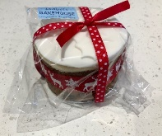
Christmas cake gift pack (3 slices) | £7.00 | Northern route, Dec 11/18th  Southern route, Dec16th/23rd | Isabel’s Bakehouse  isabel@isabelsbakehouse.com | Matured Christmas cake,decorated and wrapped  Allergens Butter, eggs flour ( wheat) port (sulphur dioxide) | 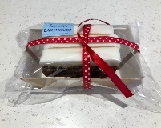
Christmas cake loaf cake, 8 slices | £12 | Northern route, Dec 11/18th  Southern route, Dec16th/23rd | Isabel’s Bakehouse  isabel@isabelsbakehouse.com | Matured Christmas cake, sliced  Allergens Butter, eggs flour ( wheat) port (sulphur dioxide) | 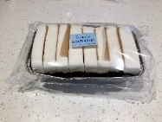
Large Gingerbread Men, 4 pack | £4.50 | Northern route, Dec 11/18th  Southern route, Dec16th/23rd | Isabel’s Bakehouse  isabel@isabelsbakehouse.com | A perfect treat or gift!  Allergens Butter, eggs flour,(wheat) smarties (chocolate)
Luxury Mince Pies, 4 pack | £5.50 | Northern route, Dec 11/18th  Southern route, Dec16th/23rd | Isabel’s Bakehouse  isabel@isabelsbakehouse.com | Sweet pastry filled with delicious award-winning boozy mincemeat (from The Preservation Society)  Allergens: Butter, eggs, Flour (wheat), Contains Nuts | 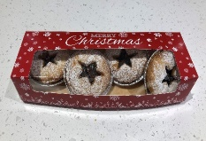
Giant cranberry, orange & white chocolate chunk muffins, 4 pack | £4.75 | Northern route, Dec 11/18th  Southern route, Dec16th/23rd | Isabel’s Bakehouse  isabel@isabelsbakehouse.com | Springy fruity muffins, the perfect snack!  Allergens: Butter, eggs, Flour (wheat), white chocolate | 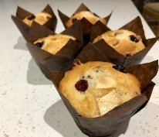
Giant Chocolate Orange Muffins, 4 pack | £4.75 | Northern route, Dec 11/18th  Southern route, Dec16th/23rd | Isabel’s Bakehouse  isabel@isabelsbakehouse.com | Extra rich chocolate orange muffins, the perfect snack!  Allergens: Butter, eggs, Flour (wheat), dark chocolate | 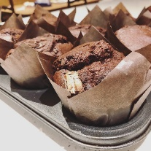
Chocolate Orange Tiffin Traybake 9 slices | £6.00 | Northern route, Dec 11/18th  Southern route, Dec16th/23rd | Isabel’s Bakehouse  isabel@isabelsbakehouse.com | Delicious chocolate orange tiffin  Allergens: Butter, dark chocolate, digestives (wheat) | 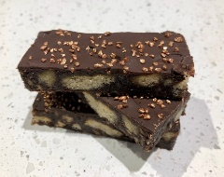
Luxury Sherry Soaked Christmas cake 6”, 7” or 8” round, topped with homemade marzipan and royal icing and seasonal decorations | £16.50 (6”)  £19 (7”)  £25 (8”) | Northern route, Dec 18th  Southern route, Dec 23rd | Judith- Cooks of Country Markets  judith_williams-1@tiscali.co.uk | Contains; Cake; currants, sultanas (SULPHITES), raisins, glace cherries, orange, sherry, margarine( BUTTER), sugar, EGGS, WHEAT FLOUR, ALMONDS, black treacle, Marzipan; ALMONDS, RAW EGG, sugar. Royal icing, PASTEURISED EGG WHITE, sugar, lemon, Decoration; Sugar, Glucose Syrup, Vegetable oil, Water, Emulsifier: E471, Glycerine, Colouring, Citric Acid, Stabiliser: E413, Preservative: E202. Photo is an example, let Judith know what sort of decoration you would prefer.
Luxury Sherry Soaked Christmas cake 4” square topped with homemade marzipan and royal icing and seasonal decorations | £7.30 | Northern route, Dec 18th  Southern route, Dec 23rd | Judith- Cooks of Country Markets  judith_williams-1@tiscali.co.uk | Contains; Cake; currants, sultanas (SULPHITES), raisins, glace cherries, orange, sherry, margarine( BUTTER), sugar, EGGS, WHEAT FLOUR, ALMONDS, black treacle, Marzipan; ALMONDS, RAW EGG, sugar. Royal icing, PASTEURISED EGG WHITE, sugar, lemon, Decoration; Sugar, Glucose Syrup, Vegetable oil, Water, Emulsifier: E471, Glycerine, Colouring, Citric Acid, Stabiliser: E413, Preservative: E202. Photo is an example, let Judith know what sort of decoration you would prefer. | See above but it’s a different shape and has no icing etc down the sides
Butter sponge cake, filled with rich butter cream, decorated with marzipan and royal icing and seasonal decorations. 7” square or 8” round (please specify which) | £11.20 | Northern route, Dec 18th  Southern route, Dec 23rd | Judith- Cooks of Country Markets  judith_williams-1@tiscali.co.uk | Cake contains; WHEAT FLOUR, sugar, MARGARINE (BUTTER) EGGS, Marzipan contains ALMONDS, RAW EGG, sugar, Icing and decoration contains Sugar, Glucose Syrup, Vegetable oil, Water, Emulsifier: E471, Glycerine, Colouring, Citric Acid, Stabiliser: E413, Preservative: E202. Photo is an example, let Judith know what sort of decoration you would prefer.
Vegan friendly chocolate cake with seasonal decoration. 7” round | £8.50 | Northern route, Dec 18th  Southern route, Dec 23rd | Judith- Cooks of Country Markets  judith_williams-1@tiscali.co.uk | Contains, WHEAT, cocoa, dark sugar, coconut oil, cider vinegar, dark chocolate, bicarbonate of soda, salt.  Decoration is also vegan friendly but does contain titanium dioxide and iron oxide.

SWEETS AND CHOCOLATES
Item | Price | Available for delivery on | Producer Name | Notes, including allergy advice | Photo available | No ordered | Delivery date
Luxury selection box of 12 chocolates | £8.00 | Northern route, Dec 18th  Southern route, Dec 23rd | Fatcat Fine Chocolate (also known as Cooks of Country Markets-Martin)
Dark Choc Truffles 70g | £3.50 | Northern route, Dec 18th  Southern route, Dec 23rd | Fatcat Fine Chocolate (also known as Cooks of Country Markets-Martin) |  | 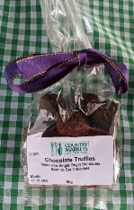
Xmas Spiced Truffles 70g | £3.50 | Northern route, Dec 18th  Southern route, Dec 23rd | Fatcat Fine Chocolate (also known as Cooks of Country Markets-Martin)
Whisky Truffles 70g | £4.00 | Northern route, Dec 18th  Southern route, Dec 23rd | Fatcat Fine Chocolate (also known as Cooks of Country Markets-Martin) |  | 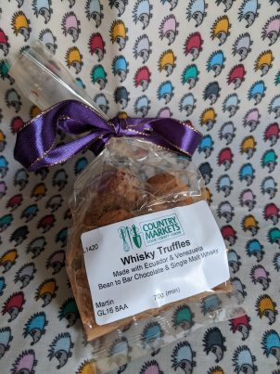
Orange Thins 64gms | £3.00 | Northern route, Dec 11/18th  Southern route, Dec 16th/23rd | Fatcat Fine Chocolate (also known as Cooks of Country Markets-Martin) |  | 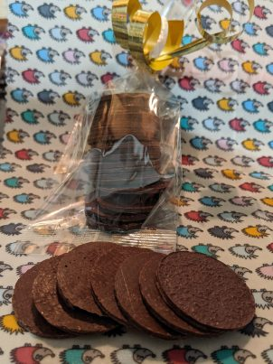
Mint Thins 64g | £3.00 | Northern route, Dec 11/18th  Southern route, Dec 16th/23rd | Fatcat Fine Chocolate (also known as Cooks of Country Markets-Martin)
Fudge 140gms | £3.00 | Northern route, Dec 11/18th  Southern route, Dec 16th/23rd | Fatcat Fine Chocolate (also known as Cooks of Country Markets-Martin)
Fudge 280gms | £6.00 | Northern route, Dec 11/18th  Southern route, Dec 16th/23rd | Fatcat Fine Chocolate (also known as Cooks of Country Markets-Martin)
Very Hot Chilli Chocolate bar 48g | £3.00 | Northern route, Dec 11/18th  Southern route, Dec 16th/23rd | Fatcat Fine Chocolate (also known as Cooks of Country Markets-Martin) |  | 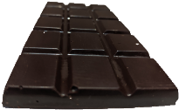
80% Dark Venezuelan Chocolate Bar 48g | £2.00 | Northern route, Dec 11/18th  Southern route, Dec 16th/23rd | Fatcat Fine Chocolate (also known as Cooks of Country Markets-Martin)

Savoury Bakes
Item | Price | Available for delivery on | Producer Name | Notes, including allergy advice | Photo available | No ordered | Delivery date
Festive Chicken and Leek Family Pie A classic combo, given a little Festive snowflake make-over! Free-range chicken and leeks in a creamy sauce wrapped up in a hot crust pastry case. A generous 2.5 kilo pie, enough to easily feed 6 people. | £24 | Northern route, Dec 11/18th  Southern route, Dec  16th/23rd | The Parsons Nose | Chicken, ham, pastry (wheat flour, water, eggs, lard, salt) milk, butter, leek, wheat flour, chicken stock, double cream, nutmeg, lemon juice, mustard, salt and pepper | 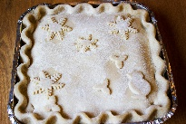
Festive Steak and Ale Family Pie We've given our next level pie, succulent Hereford beef and hearty Guinness a Christmas make-over! This generous family pie, comes frozen, so you can pop in deepfreeze or thaw and cook from chilled. Perfect for hassle free delicious family meals. 2.5 kilo enough to easily feed 6 people. | £26 | Northern route, Dec 11/18th  Southern route, Dec  16th/23rd | The Parsons Nose | Beef, pastry ( wheat flour, water, eggs, lard, salt) Guinness beer, beef stock, gravy browning, tomato puree, onion, basil, garlic, salt and pepper. | 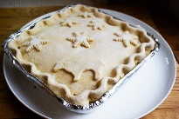
Festive Venison and red wine Family Pie A pie with real body. Delicious prime cuts of Forest of Dean venison in a deep red wine sauce. Venison is low in saturated fat and high in protein. 2.5 kilo enough to easily feed 6 people |  | Northern route, Dec 11/18th  Southern route, Dec  16th/23rd | The Parsons Nose | Ingredients: Venison, red wine, pastry (wheat flour, water, eggs, lard, salt) tomato puree onion, meat stock, gravy browning, garlic basil, sunflower oil,salt and pepper

MEAT
Item | Price | Available for delivery on | Producer name and Contact Details. | Notes, including allergy advice | No ordered | Aprox weight (if relevant) | Delivery date
White turkey 3.6 to 10.8kg (8-20lbs) | £9.90/kg | Dec 23rd | Model Farm | Free range, please specify the approximate weight you would prefer
White turkey 3.6 to 10.8kg (8-20lbs), cut into portions (crown, legs etc precut into meal sized portions to share between households or freeze for later | £9.90 kg | Dec 23rd | Model Farm | Free range, please specify the approximate weight you would prefer
Bronze turkey 3.6-10.8kg (8-20lbs) | £10.90/kg | Dec 23rd | Model Farm | Free range, please specify the approximate weight you would prefer
Bronze turkey 3.6-10.8kg (8-20lbs) cut into portions (crown, legs etc precut into meal sized portions to share between households or freeze for later) | £10.90/kg | Dec 23rd | Model Farm | Free range, please specify the approximate weight you would prefer
Organic white turkey 5-7kg (6-16lbs | £12.90/kg | Dec 23rd | Model Farm | Free range/organic, please specify the approximate weight you would prefer
Organic white turkey 5-7kg (6-16lbs cut into portions (crown, legs etc precut into meal sized portions to share between households or freeze for later) | £12.90/kg | Dec 23rd | Model Farm | Free range/organic, please specify the approximate weight you would prefer
Large cockerels 2.5-5kgs/6-11lbs | £8.90 | Dec 23rd | Model Farm | Free range, please specify the approximate weight you would prefer
Barbary Ducks 2.5-3.6kg/6-8lbs | £9.90/kg | Dec 23rd | Model Farm | Free range, please specify the approximate weight you would prefer between 6lbs (2.7kg) and 8lbs (3.6kg)
Pheasants | £5.00 each | Dec 23rd | Model Farm
Free range geese 4-7kg, 9-15lbs | £14.90 kg | Dec 23rd | Model Farm | Free range, please specify the approximate weight you would prefer
5kg special Huntsham pork and beef box | £67.50 | Northern route Dec 18^{th,} Southern Route Dec 23rd | Huntsham Court Farm | Box contains; 1 middle white pork roasting joint 1.5kg, 1 longhorn beef roasting joint 1.5kg, pork sausages 1kg (3 packs of 6), beef mince 1kg(2 packs 500gms)
Pork roasting joint 1.5kg from rare breed middle white pigs | £20.45 | Northern route Dec 18^{th.} Southern Route Dec 23rd | Huntsham Court Farm | Price includes the bone, if you would like this removed and the joint rolled let us know
Beef 1.5kg roasting joint, from rare breed Longhorn Cattle - hung minimum 32 days | £20.45 | Northern route Dec 18^{th,} Southern Route Dec 23rd | Huntsham Court Farm | Price includes the bone, if you would like this removed and the joint rolled let us know
Boneless gammon unsmoked, | £8.90kg | Dec 23rd | Model Farm | From free range pigs. please specify the weight you want in kgs
Boneless gammon smoked | £8.90 kg | Dec 23rd | Model Farm | From free range pigs. please specify the weight you want in kgs
Pork sausagemeat  0.5kg packs | £4.30 | Northern route, Dec 11/18th  Southern route, Dec16th/23rd | Warrenhaven Farm | Supplied frozen
Traditional sausage meat 500gm pack | £3.75pack | Dec 23rd | Model Farm | Free range
Traditional chipolatas 500gms pack | £3.75 pack | Dec 23rd | Model Farm | Free range
Pigs in Blankets  Free range ‘Large Black’ Heritage pork  wrapped in smoked bacon. 420g | £4.65 | Northern route, Dec 11/18th  Southern route, Dec16th/23rd | The Parsons Nose | Ingredients: Pork, bacon, wheat rusk, seasoning  (wheat, celery, sulphite) salt. allergens in bold
Festive Sausage Stuffing Balls x 8 410gms | £4.95 | Northern route, Dec 11/18th  Southern route, Dec16th/23rd | The Parsons Nose | Ingredients: Pork, breadcrumbs (wheat) seasoning  (wheat, celery, sulphite) allergens in bold
Black Pudding 280gms | £4.50 | Northern route, Dec 11/18th  Southern route, Dec16th/23rd | The Parsons Nose | Ingredients Diced pork back fat, pigs blood,  barley, wheat, gluten, soya.
NB. We will charge you for the actual cost of turkeys, geese etc. based on the weight of bird that is delivered.

